VOLUMETRIC ANALYSIS

Volumetric analysis is used to determine the concentration of a solution by reacting it with a “known” solution - one with a known concentration.

Typically, volumetric analysis is used to determine the concentration of an acid or base solution.

The procedure of adding one solution to another until the reaction between them is complete is called a titration.

Usually the “known” solution is a standard solution - one that is made up in a volumetric flask very accurately.

A definite volume of one solution (determined by pipette) is placed in a conical flask with a few drops of a suitable indicator. The other solution is delivered by burette into the flask until a colour change in the indicator shows that the reaction has reached neutrality (i.e. gone to completion).



DEFINITIONS

EQUIVALENCE POINT: where chemically equivalent amounts of acid and base have been
added.

END POINT: where the indicator changes colour.

An indicator is chosen such that the equivalence point and end point are as close together as possible.

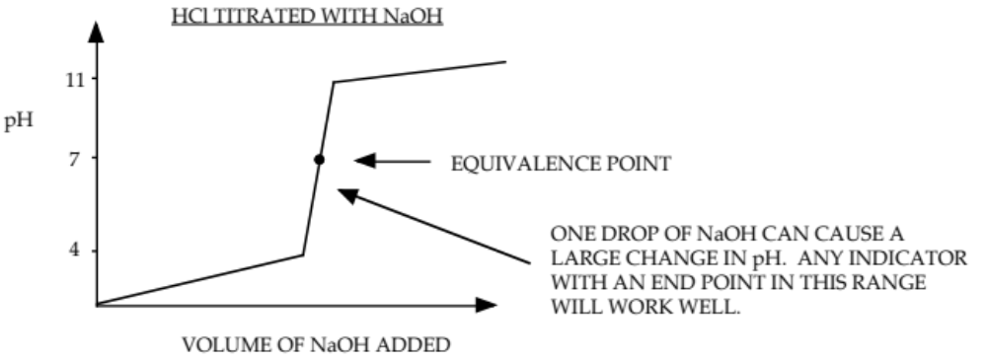

From the above diagram, it is evident that a single drop of one solution can change the pH drastically. Typical indicators that can be used are shown below.

INDICATOR END POINT COLOUR CHANGE
(pH scale) (acid --> base)

phenolphthalein 8.0 - 10.0 colourless --> pink

bromothymol blue 6.2 - 7.6 yellow --> blue

methyl red 4.4 - 6.2 red --> yellow

Phenolphthalein is the best indicator to use for strong acid-strong base titrations since its colour change is very easy to detect.

